EXPERIMENT NO. 4

AIM :- Write a C program for dividing the given input program into lexemes. and also simulate lexical analyzer for validating operators

ASSUMPTIONS:-

1. The string length is of maximum 50 characters
2. The length of identifier is maximum 8 char, first character is alphabet after that it may be an alphabet/digit

ALGORITHM:-

Step 1: Declare the necessary variables.

Step 2: Declare an array and store the keywords in that array

Step 3: Open the input file in read open

Step 4: read the string from the file till the end of file.

i) If the first character in the string is # then print that string as header file

ii) If the string matches with any of the keywords print that string is a keyword

iii) If the string matches with operator and special symbols print the corresponding message

iv) If the string is not a keyword then print that as an identifier.

CODE:-

#include<stdio.h>

#include<stdlib.h>

#include<string.h>

#include<ctype.h>

int isKeyword(char buffer[])

{

char keywords[32][10] = {"auto","break","case","char","const","continue","default","do","double","else","enum","extern","float","for","goto","if","int","long","register","return","short","signed","sizeof","static","struct","switch","typedef","union","unsigned","void","volatile", "while"};

int i, flag = 0;

for(i = 0; i < 32; ++i)

{

 if(strcmp(keywords[i], buffer) == 0)

{

  flag = 1;

break;

 }

}

return flag;

}

int main()

{

char ch, buffer[15], operators[] = "+-\*/%=";

FILE \*fp;

int i,j=0;

fp = fopen("program.txt","r");

if(fp == NULL)

{

printf("error while opening the file\n");

exit(0);

}

while((ch = fgetc(fp)) != EOF)

{

for(i = 0; i < 6; ++i)

{

if(ch == operators[i])

printf("%c is operator\n", ch);}

    if(isalnum(ch))

{

     buffer[j++] = ch;

  }

else if((ch == ' ' || ch == '\n') && (j != 0))

{

buffer[j] = '\0';

j = 0;

if(isKeyword(buffer) == 1)

printf("%s is keyword\n", buffer);

else

printf("%s is indentifier\n", buffer);

}

}

fclose(fp);

return 0;

}

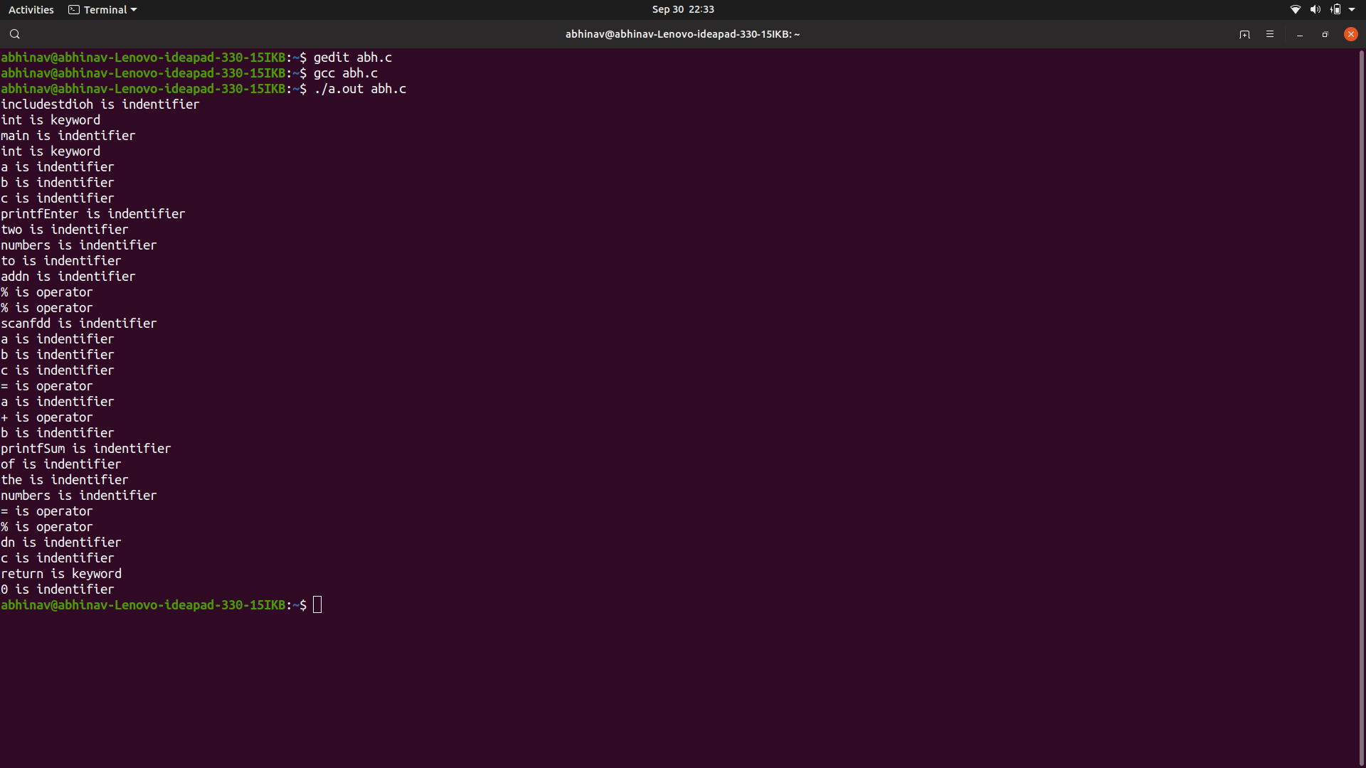

RESULT:- Thus, C program for dividing the given input program into lexemes and also simulate lexical analyzer for validating operators has been successfully executed.